Step 1 : Log in to Qmetry with your credentials and go to Automation tab -🡪 Automation agent.

In section “Use Automation Agent Key to configure Agent” click on link **Generate Key**

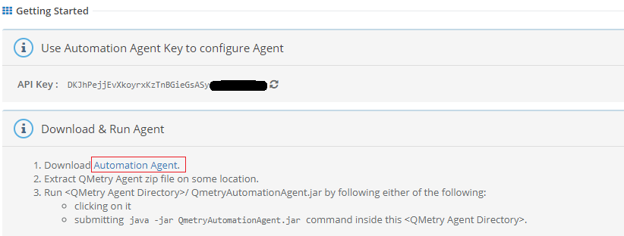

Step 2: Download automation agent in local drive (not on network drive). After downloading unzip the folder and double click

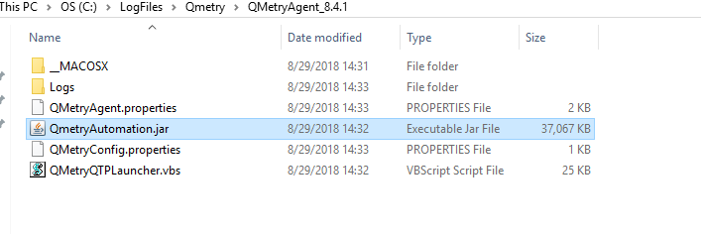

Step 3: Qmetry Url and key settings

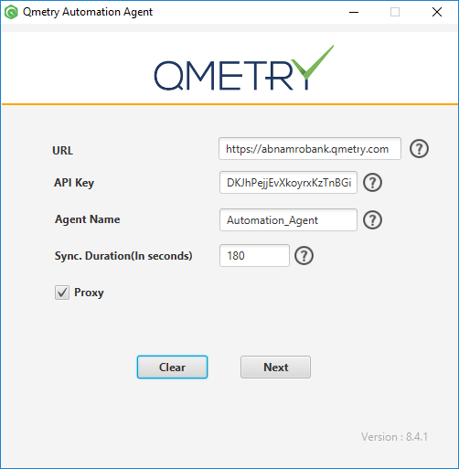

Provide below Details:

URL : <https://abnamrobank.qmetry.com>

API Key : The key which you have generated in step 1

Agent Name : Give name of your choice

Sync Duration : keep as it is

Tick Proxy

Step 4 : Qmetry Proxy settings

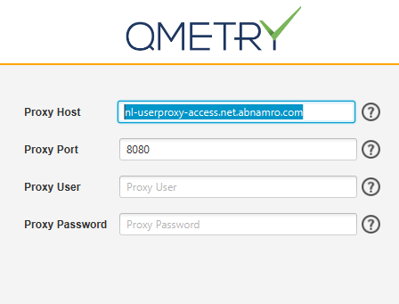

Proxy url : nl-userproxy-access.net.abnamro.com

Port : 8080

Leave rest blank and click start.